Wavy Shapes
# Source: AI Source: Provided by: [Data Path: Persons Table -> ID Column: 1, Name_En Column: Motasem Essam] -> From: [ChatGPT] on [7/25/2026]
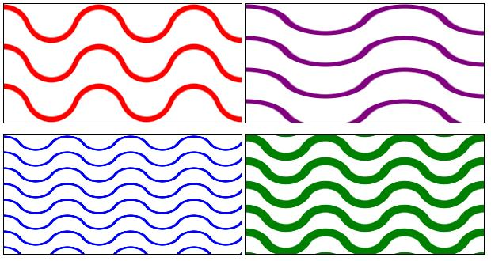
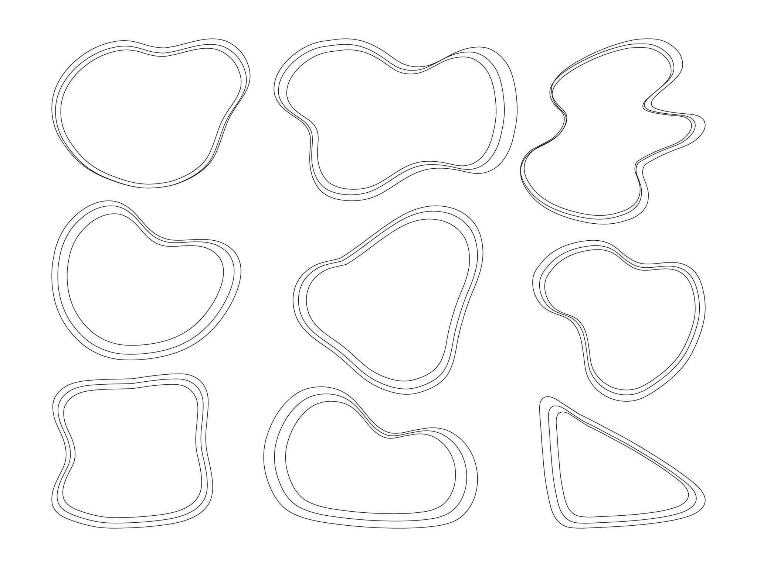
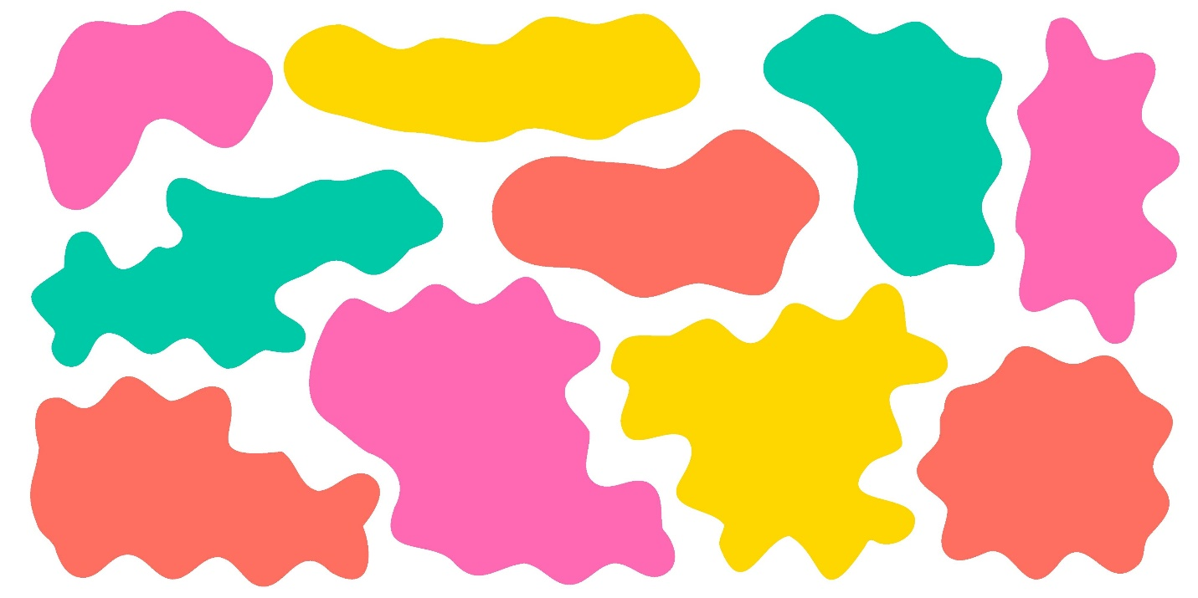
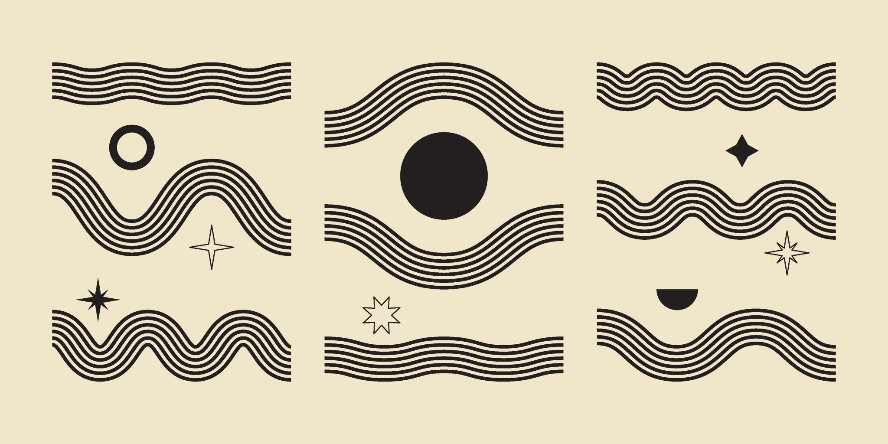
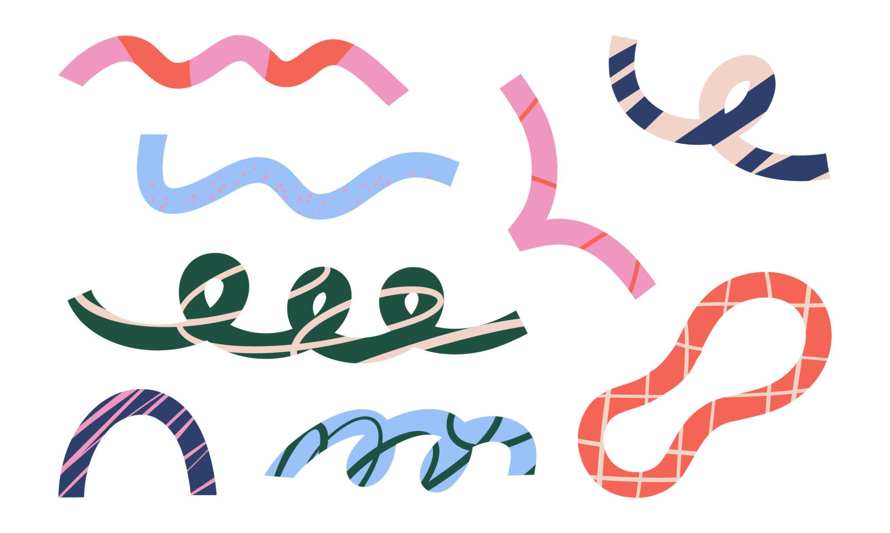
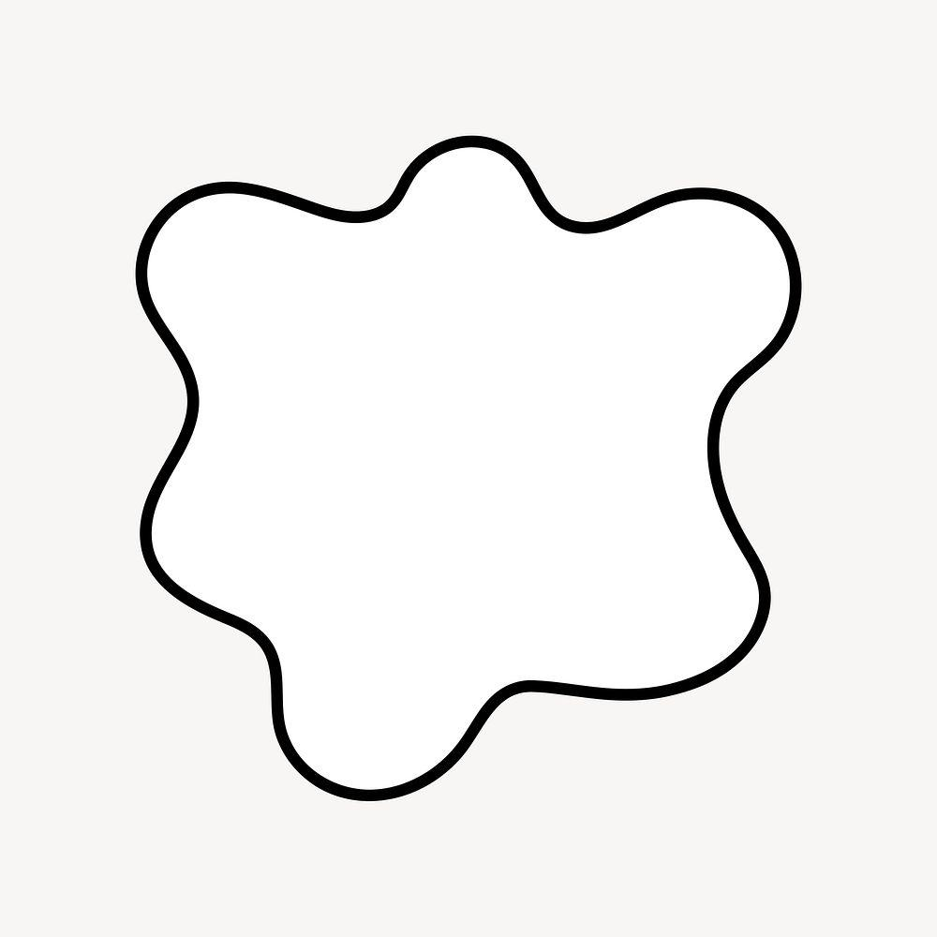

Definition
# Source: AI Source: Provided by: [Data Path: Persons Table -> ID Column: 1, Name_En Column: Motasem Essam] -> From: [ChatGPT] on [7/25/2026]
A Wavy Shape is a shape or form whose boundary follows a smooth, continuously changing, wave-like path, typically consisting of alternating rises and falls.
Unlike a zigzag shape, which changes direction through sharp vertices, a wavy shape generally changes direction smoothly without sharp corners.

Fundamental Concept
# Source: AI Source: Provided by: [Data Path: Persons Table -> ID Column: 1, Name_En Column: Motasem Essam] -> From: [ChatGPT] on [7/25/2026]
The defining characteristic of a wavy shape is smooth, repeated variation in direction.
A simple wavy form can be represented as:
___ ___
/ \___/ \___
The boundary contains alternating:
- Peaks
- Valleys
- Rises
- Falls
- Smooth curves
The exact size, spacing, and height of the waves do not have to be uniform.

Main Characteristics
# Source: AI Source: Provided by: [Data Path: Persons Table -> ID Column: 1, Name_En Column: Motasem Essam] -> From: [ChatGPT] on [7/25/2026]
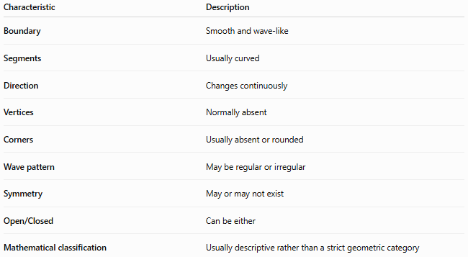
Characteristic | Description
Boundary | Smooth and wave-like
Segments | Usually curved
Direction | Changes continuously
Vertices | Normally absent
Corners | Usually absent or rounded
Wave pattern | May be regular or irregular
Symmetry | May or may not exist
Open/Closed | Can be either
Mathematical classification | Usually descriptive rather than a strict geometric category

Basic Structure
# Source: AI Source: Provided by: [Data Path: Persons Table -> ID Column: 1, Name_En Column: Motasem Essam] -> From: [ChatGPT] on [7/25/2026]
A wavy boundary can be viewed as a sequence of smooth rises and falls:
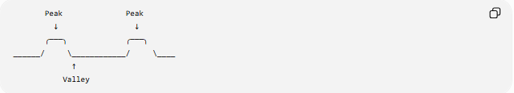
Peak Peak
↓ ↓
╭───╮ ╭───╮
______/ \____________/ \____
↑
Valley
Unlike a polygon, the boundary does not consist of straight segments meeting at sharp vertices.

Types of Wavy Shapes
# Source: AI Source: Provided by: [Data Path: Persons Table -> ID Column: 1, Name_En Column: Motasem Essam] -> From: [ChatGPT] on [7/25/2026]
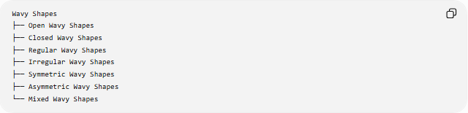
Wavy Shapes
├── Open Wavy Shapes
├── Closed Wavy Shapes
├── Regular Wavy Shapes
├── Irregular Wavy Shapes
├── Symmetric Wavy Shapes
├── Asymmetric Wavy Shapes
└── Mixed Wavy Shapes

1-Open Wavy Shapes
# Source: AI Source: Provided by: [Data Path: Persons Table -> ID Column: 1, Name_En Column: Motasem Essam] -> From: [ChatGPT] on [7/25/2026]
An Open Wavy Shape is a wave-like path whose endpoints do not connect.
Example:
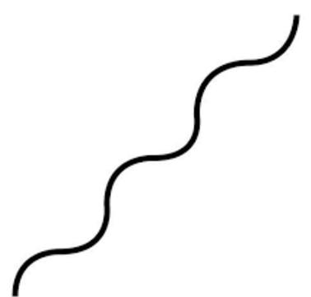
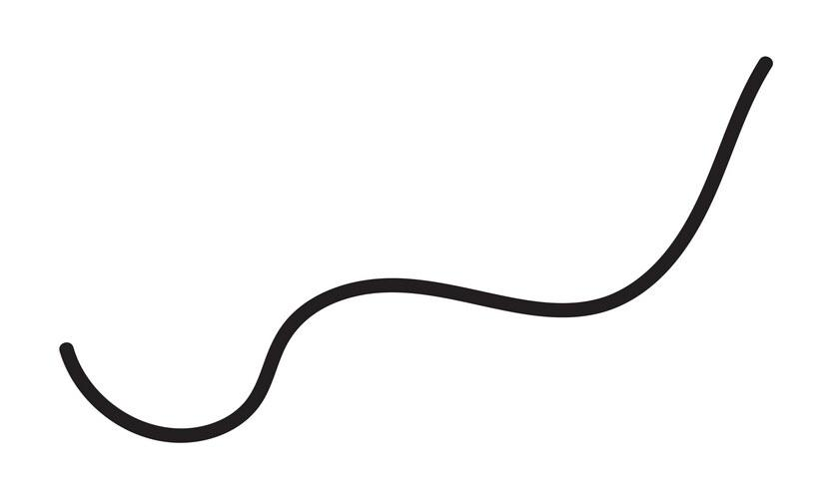
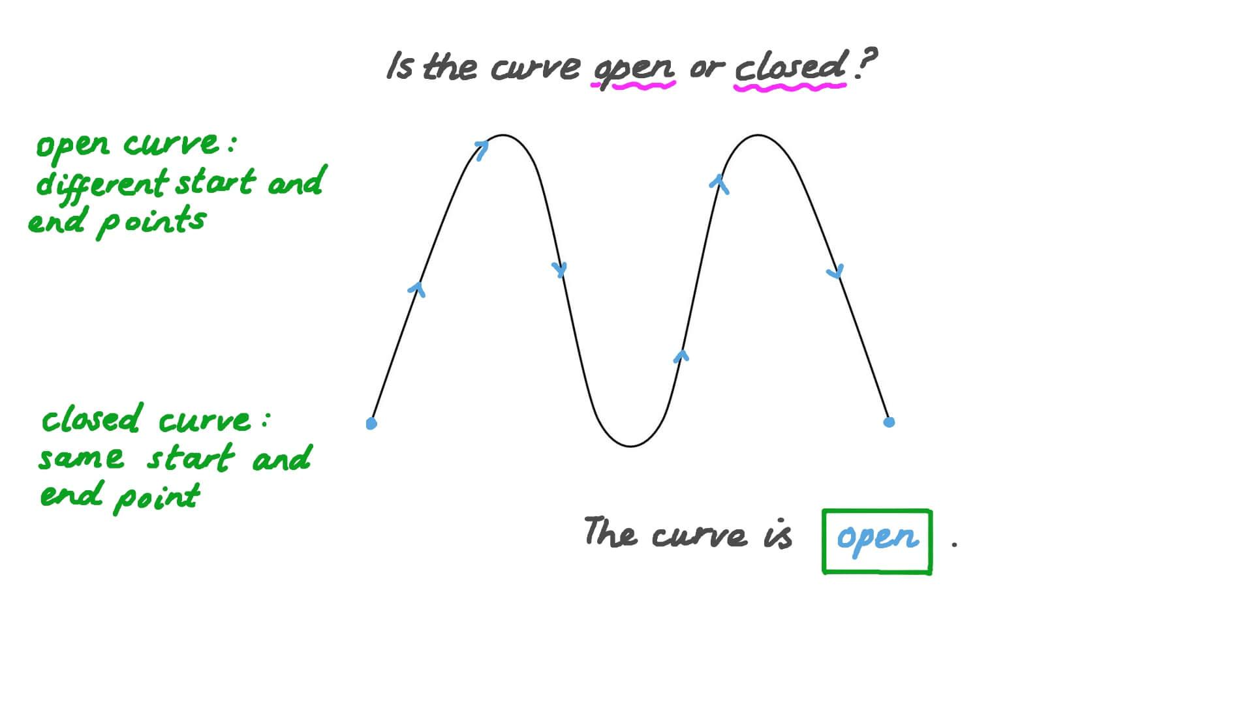
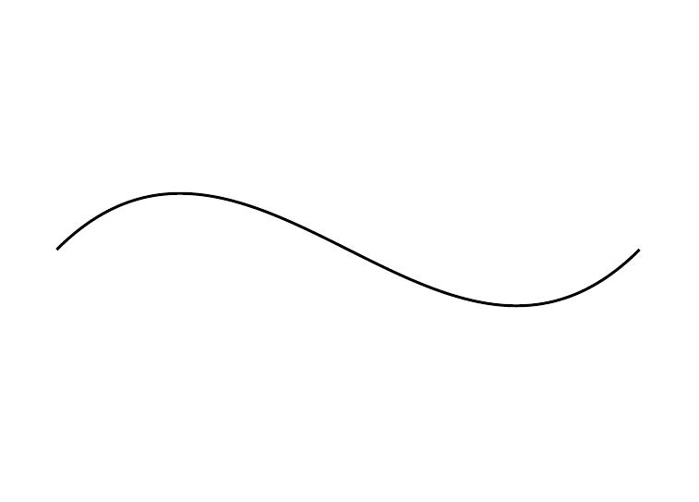
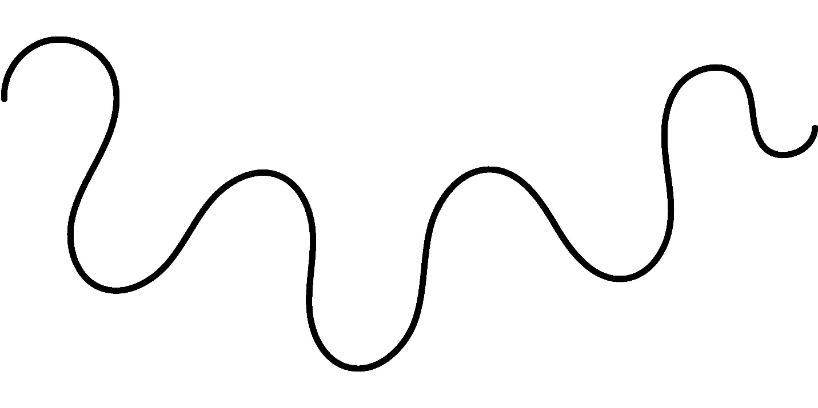
~~~~~~~∿~~~~~~~∿~~~~
It forms a wavy curve or path, rather than an enclosed region.

2-Closed Wavy Shapes
# Source: AI Source: Provided by: [Data Path: Persons Table -> ID Column: 1, Name_En Column: Motasem Essam] -> From: [ChatGPT] on [7/25/2026]
A Closed Wavy Shape has a continuous boundary that returns to its starting point and encloses a region.
Example:
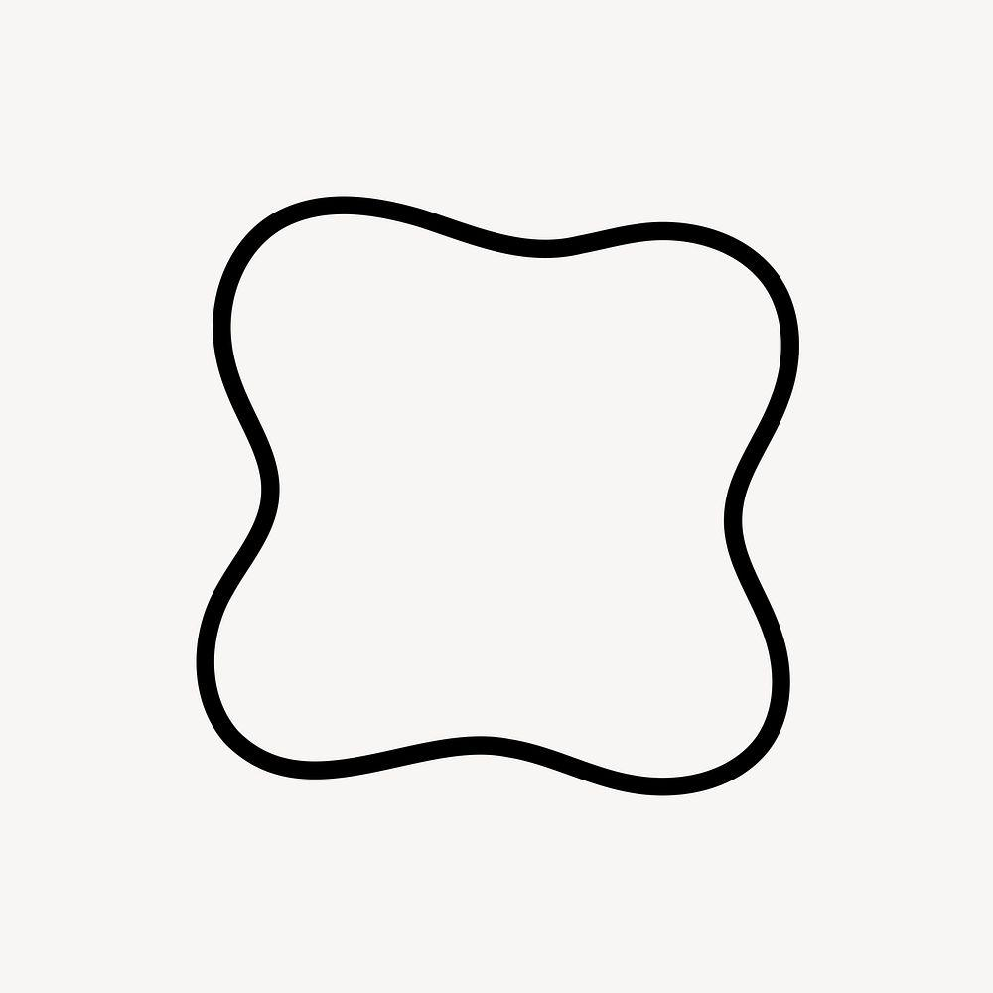
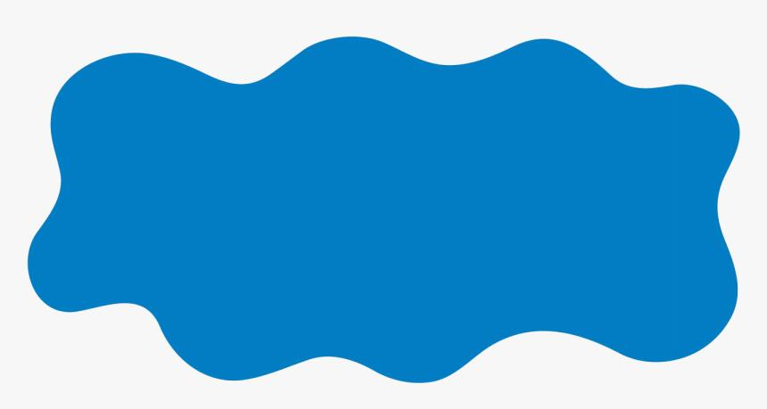
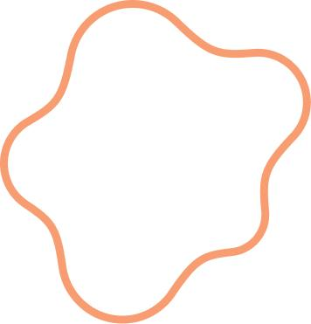
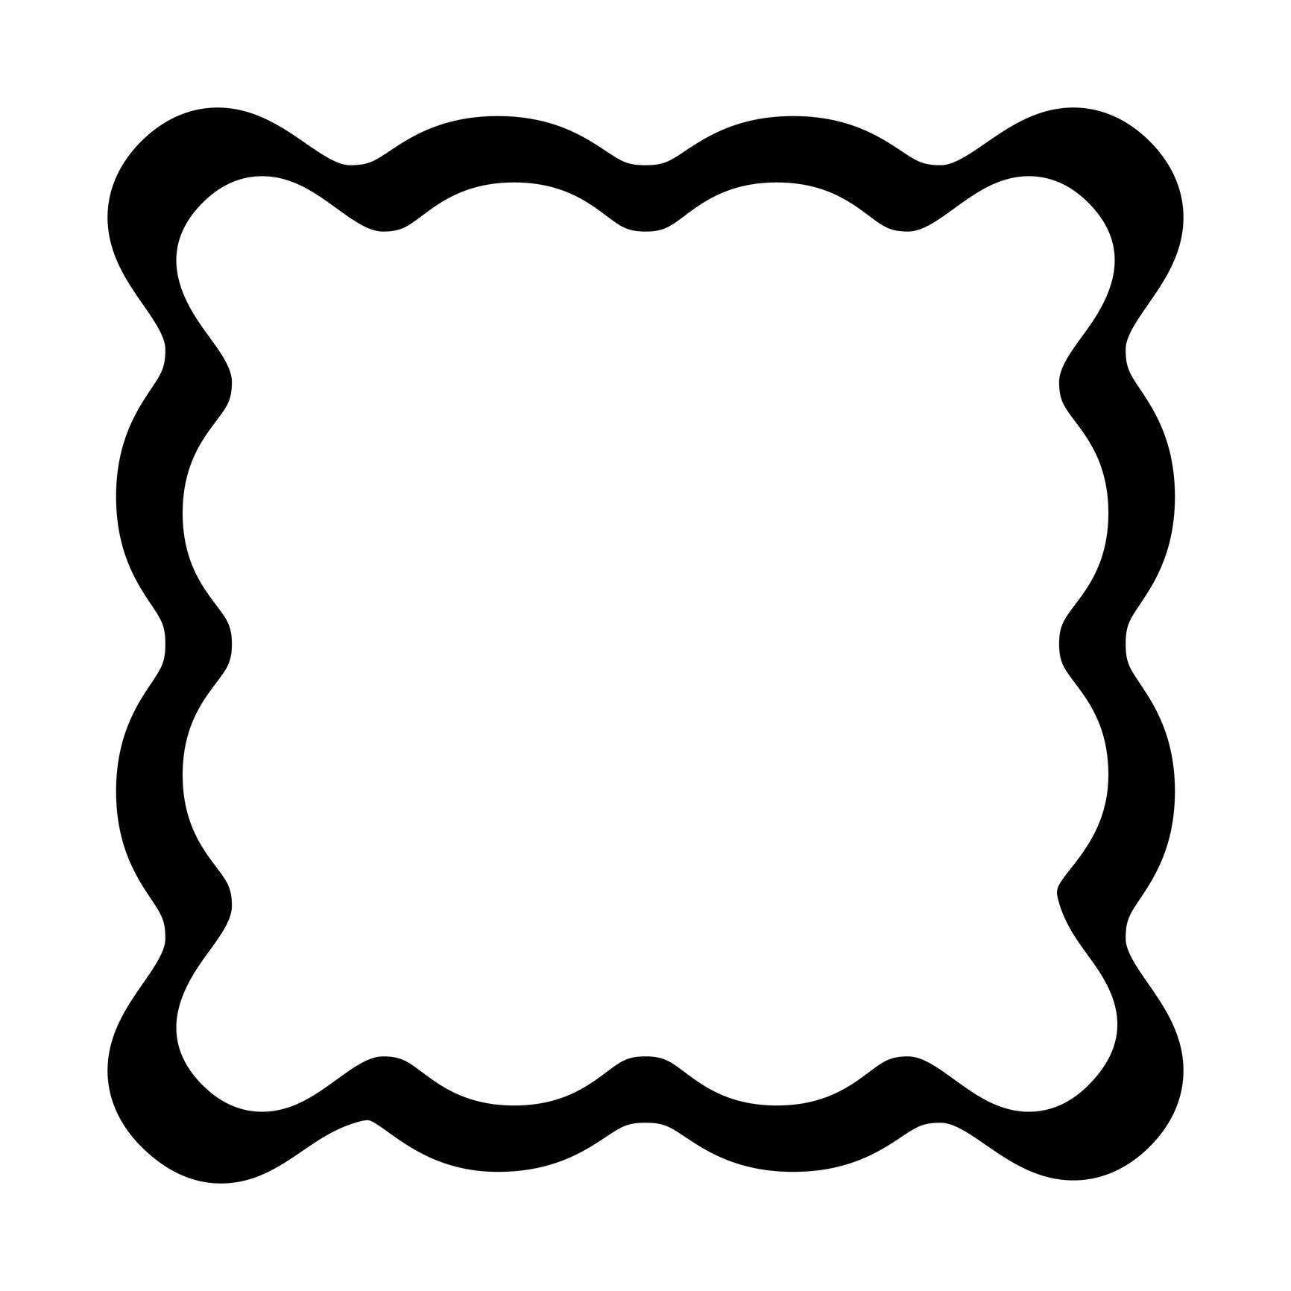
Examples include:
- Wavy blobs
- Scalloped shapes
- Irregular rounded forms
- Decorative enclosed shapes

3-Regular Wavy Shapes
# Source: AI Source: Provided by: [Data Path: Persons Table -> ID Column: 1, Name_En Column: Motasem Essam] -> From: [ChatGPT] on [7/25/2026]
A Regular Wavy Shape has a repeating wave pattern with consistent or periodically repeated characteristics.
For example:
∿∿∿∿∿∿∿
The waves may have:
- Similar amplitude
- Similar wavelength
- Repeated curvature
- Regular spacing
A mathematical example is a sinusoidal curve:
$$y=Asin⁡\left(Bx+C\right)+D$$
where:
- $A$controls amplitude
- $B$controls wavelength
- $C$controls horizontal phase
- $D$controls vertical displacement

4-Irregular Wavy Shapes
# Source: AI Source: Provided by: [Data Path: Persons Table -> ID Column: 1, Name_En Column: Motasem Essam] -> From: [ChatGPT] on [7/25/2026]
An Irregular Wavy Shape has waves that vary in:
- Height
- Width
- Spacing
- Curvature
- Direction
For example:
___/‾‾\____/‾\__/‾‾‾\____
The pattern remains wave-like but is not periodic.

5-Symmetric Wavy Shapes
# Source: AI Source: Provided by: [Data Path: Persons Table -> ID Column: 1, Name_En Column: Motasem Essam] -> From: [ChatGPT] on [7/25/2026]
A Symmetric Wavy Shape has a recognizable symmetry.
For example, a closed wavy shape may have:
- Vertical reflection symmetry
- Horizontal reflection symmetry
- Rotational symmetry
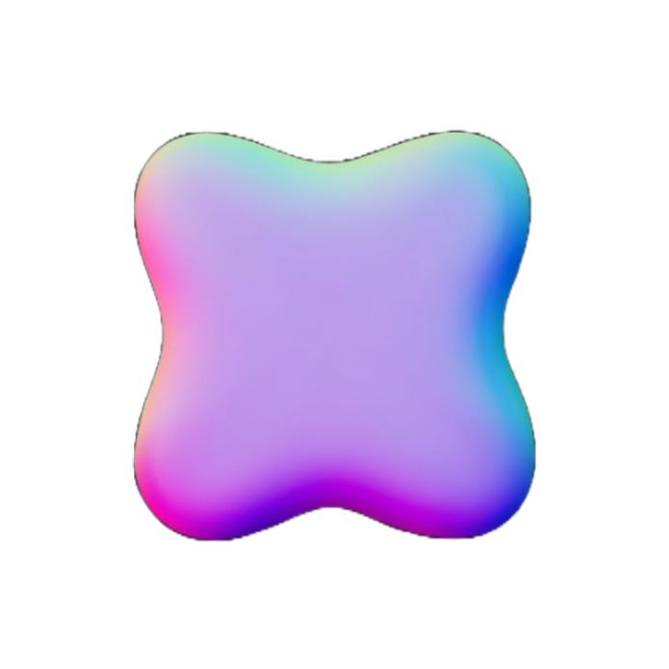

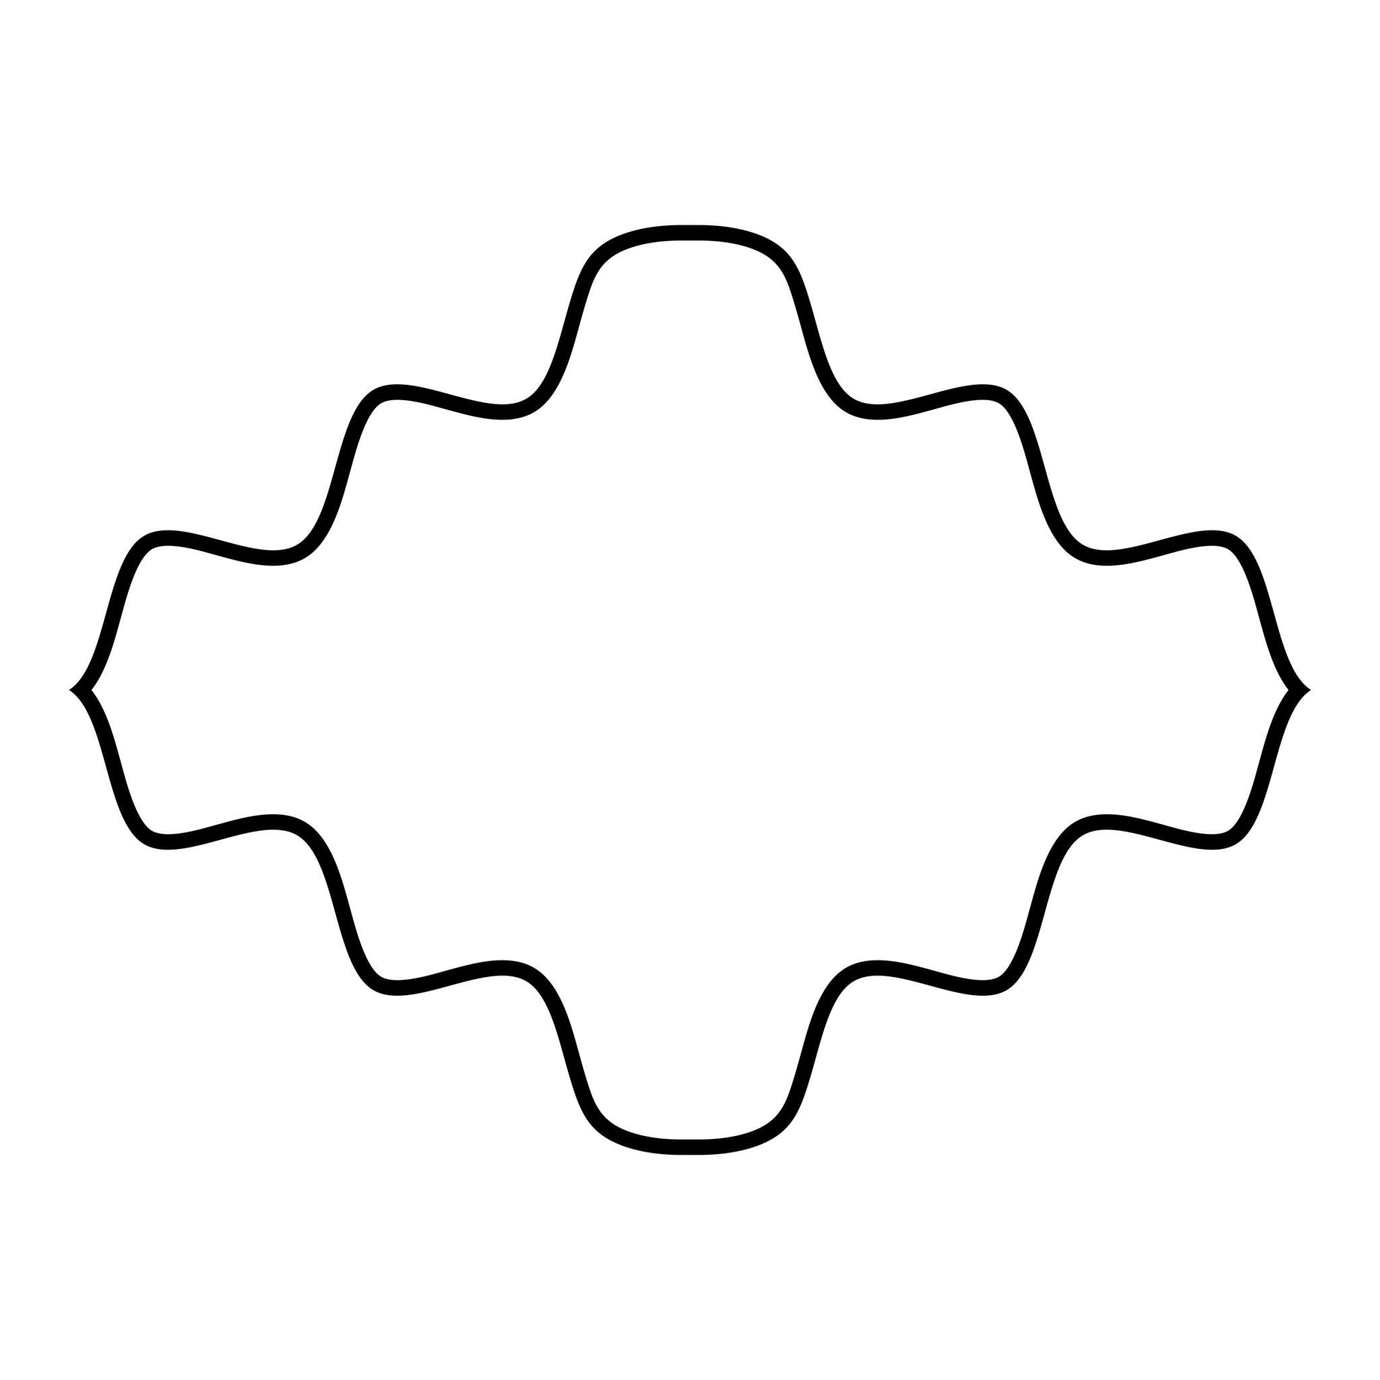

6-Asymmetric Wavy Shapes
# Source: AI Source: Provided by: [Data Path: Persons Table -> ID Column: 1, Name_En Column: Motasem Essam] -> From: [ChatGPT] on [7/25/2026]
An Asymmetric Wavy Shape has no corresponding line of reflection symmetry.
Its waves may have different:
- Heights
- Widths
- Curvatures
- Positions

7-Mixed Wavy Shapes
# Source: AI Source: Provided by: [Data Path: Persons Table -> ID Column: 1, Name_En Column: Motasem Essam] -> From: [ChatGPT] on [7/25/2026]
A Mixed Wavy Shape combines wavy curves with other boundary types.
For example:
Straight Segment → Wavy Curve → Arc → Wavy Curve
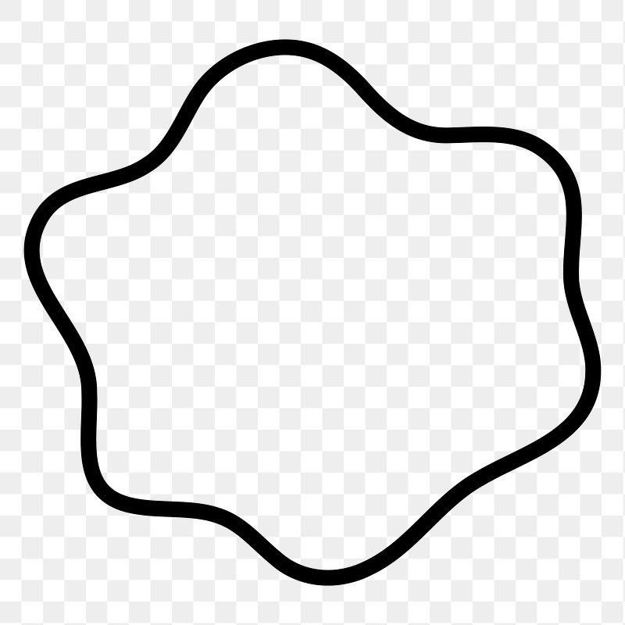
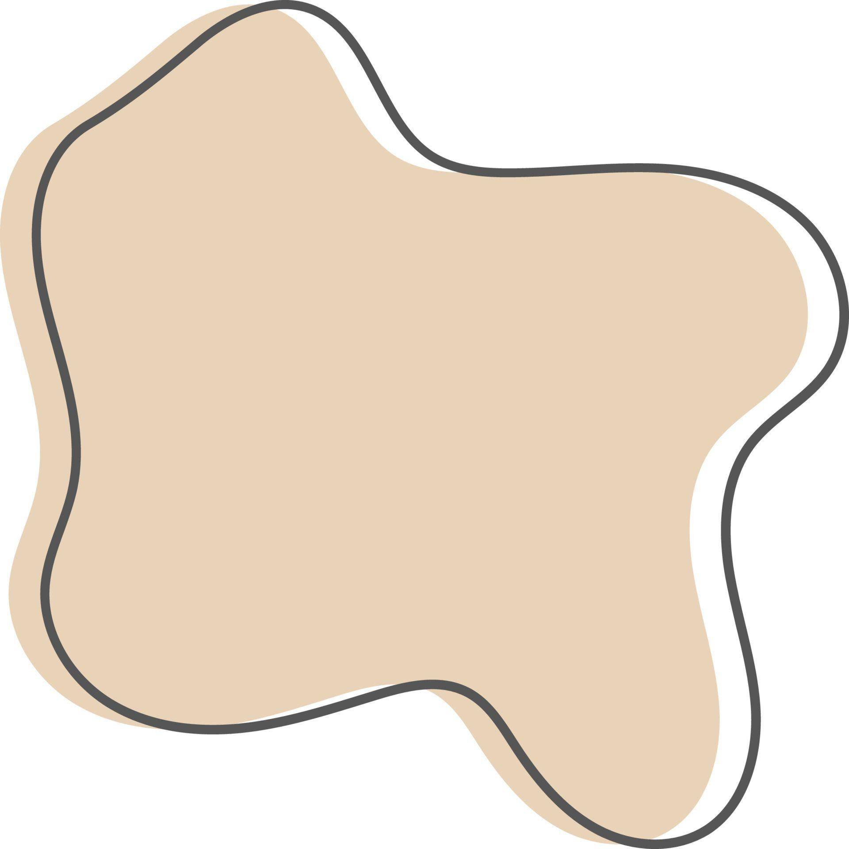
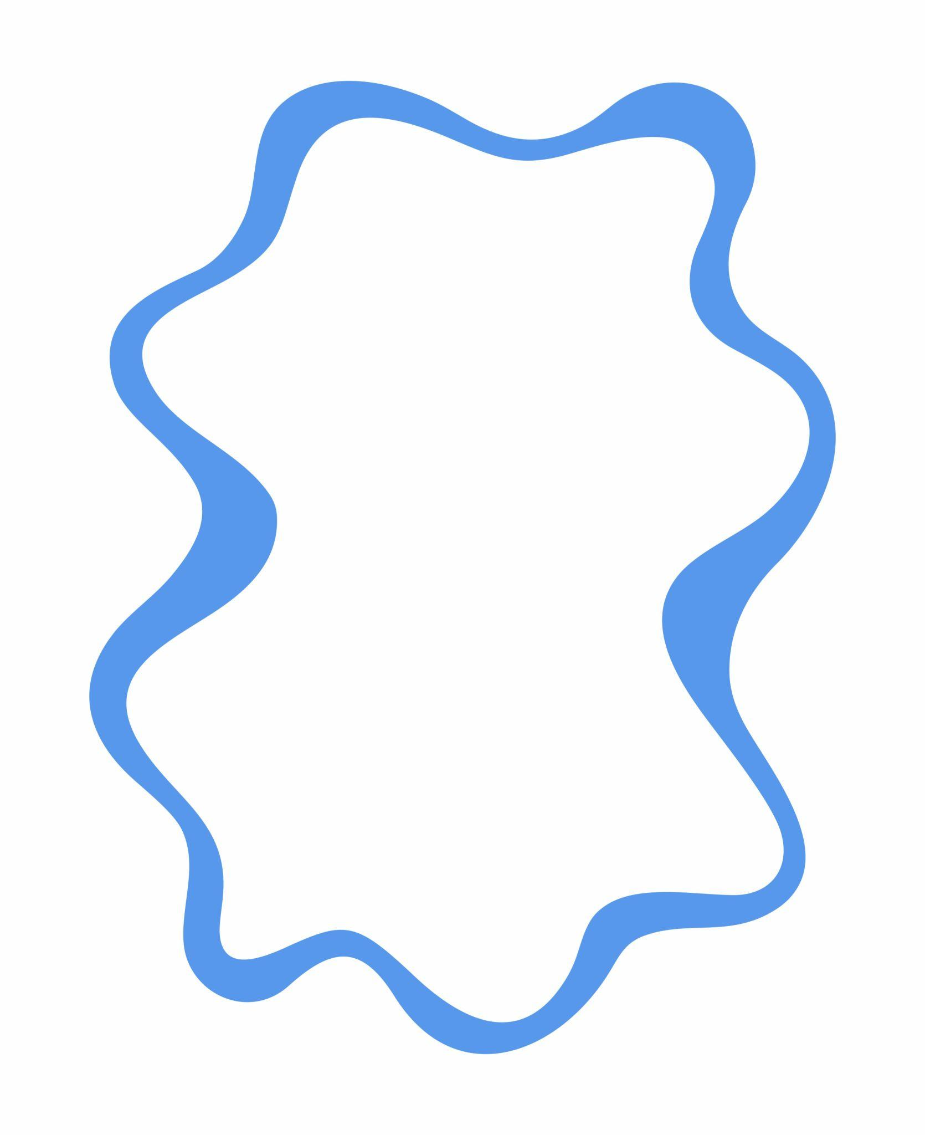
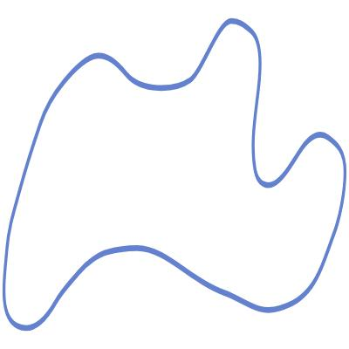
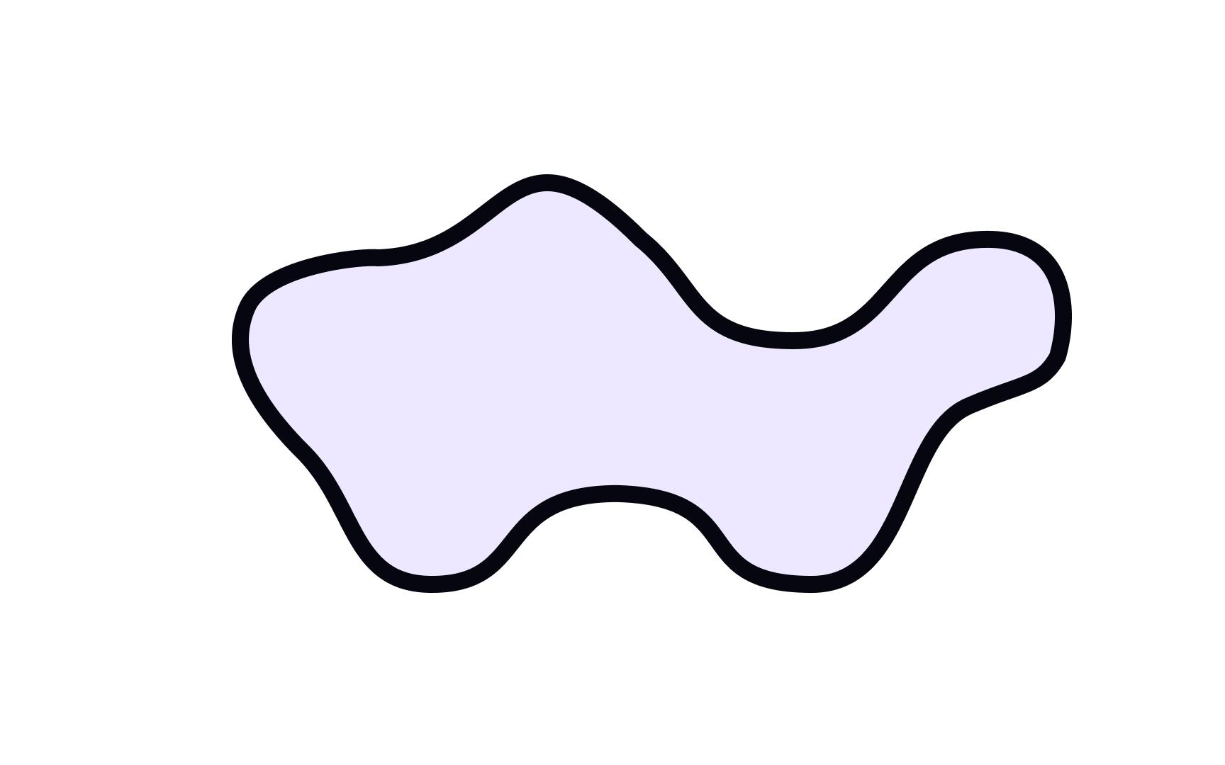

Wavy Shapes and Curves
# Source: AI Source: Provided by: [Data Path: Persons Table -> ID Column: 1, Name_En Column: Motasem Essam] -> From: [ChatGPT] on [7/25/2026]
A wavy shape is generally based on one or more curves.
A curve can change direction smoothly, whereas a polygon changes direction at discrete vertices.
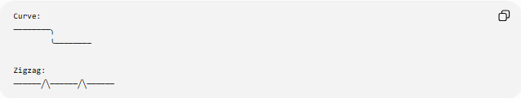
Curve:
────────╮
╰────────

Zigzag:
──────╱╲──────╱╲──────
Thus, a wavy boundary is fundamentally curvilinear rather than polygonal.

Wavy Shapes vs Zigzag Shapes
# Source: AI Source: Provided by: [Data Path: Persons Table -> ID Column: 1, Name_En Column: Motasem Essam] -> From: [ChatGPT] on [7/25/2026]
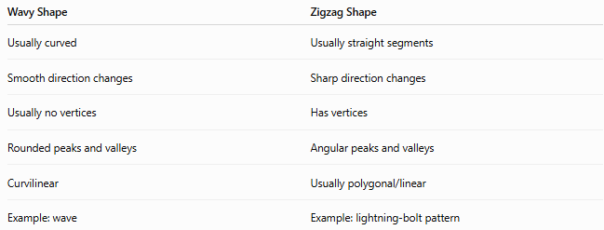
Wavy Shape | Zigzag Shape
Usually curved | Usually straight segments
Smooth direction changes | Sharp direction changes
Usually no vertices | Has vertices
Rounded peaks and valleys | Angular peaks and valleys
Curvilinear | Usually polygonal/linear
Example: wave | Example: lightning-bolt pattern
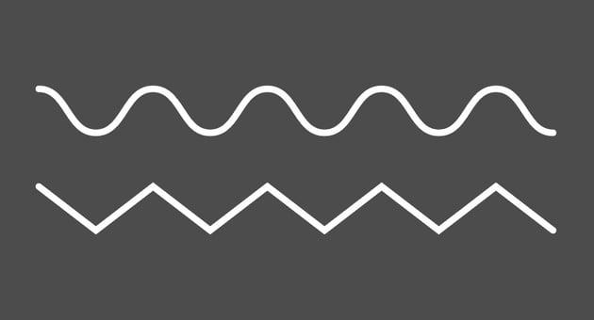
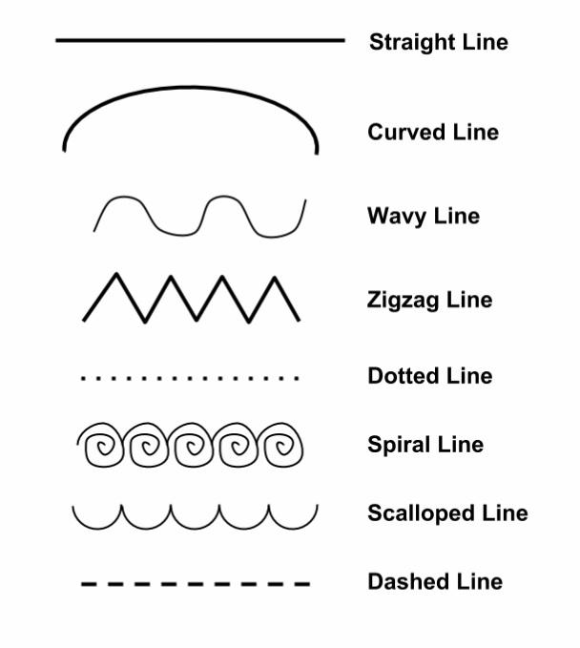
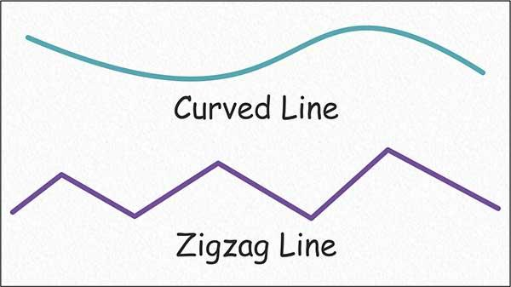

Wavy Shapes vs Freeform Shapes
# Source: AI Source: Provided by: [Data Path: Persons Table -> ID Column: 1, Name_En Column: Motasem Essam] -> From: [ChatGPT] on [7/25/2026]
Wavy and freeform describe different aspects of a shape.
- Wavy describes the appearance or pattern of the boundary.
- Freeform describes the lack of a fixed geometric structure.
Therefore, a shape can be both:
$$\boxed{\text{Wavy}+\text{Freeform}}$$
For example, an irregular smooth blob can be classified as a freeform wavy shape.

Wavy Shapes vs Organic Shapes
# Source: AI Source: Provided by: [Data Path: Persons Table -> ID Column: 1, Name_En Column: Motasem Essam] -> From: [ChatGPT] on [7/25/2026]
Wavy shapes and organic shapes can overlap.
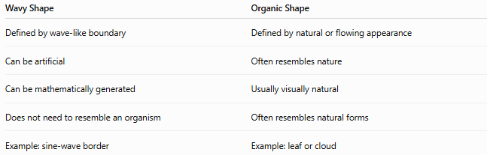
Wavy Shape | Organic Shape
Defined by wave-like boundary | Defined by natural or flowing appearance
Can be artificial | Often resembles nature
Can be mathematically generated | Usually visually natural
Does not need to resemble an organism | Often resembles natural forms
Example: sine-wave border | Example: leaf or cloud
A natural object can therefore be both organic and wavy.

Mathematical Representation
# Source: AI Source: Provided by: [Data Path: Persons Table -> ID Column: 1, Name_En Column: Motasem Essam] -> From: [ChatGPT] on [7/25/2026]
A regular wavy boundary can be represented by a periodic function such as:
$$y=Asin⁡\left(Bx\right)$$
For a more general wave:
$$y=Asin⁡\left(Bx+C\right)+D$$
An irregular wavy boundary does not necessarily have a simple mathematical equation and may instead be represented by:
- Parametric curves
- Splines
- Bézier curves
- Piecewise curves
- Digitized point data
A parametric curve can be written as:
$$x=x\left(t\right), y=y\left(t\right)$$

Examples
# Source: AI Source: Provided by: [Data Path: Persons Table -> ID Column: 1, Name_En Column: Motasem Essam] -> From: [ChatGPT] on [7/25/2026]
Common examples of wavy shapes include:
- Waves on water
- Wavy borders
- Scalloped outlines
- Smooth decorative curves
- Wavy ribbons
- Cloud-like outlines
- Irregular blobs
- Undulating boundaries
- Wavy artistic forms
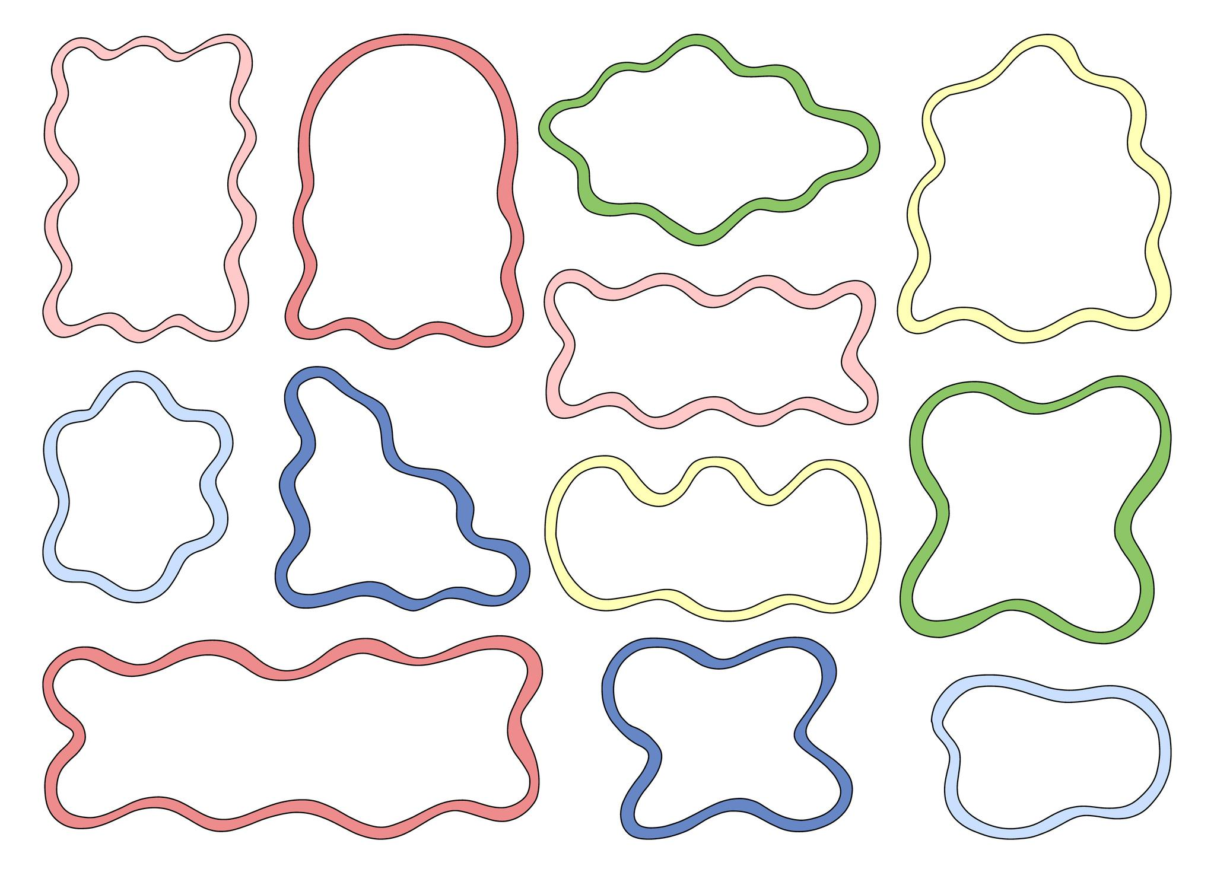
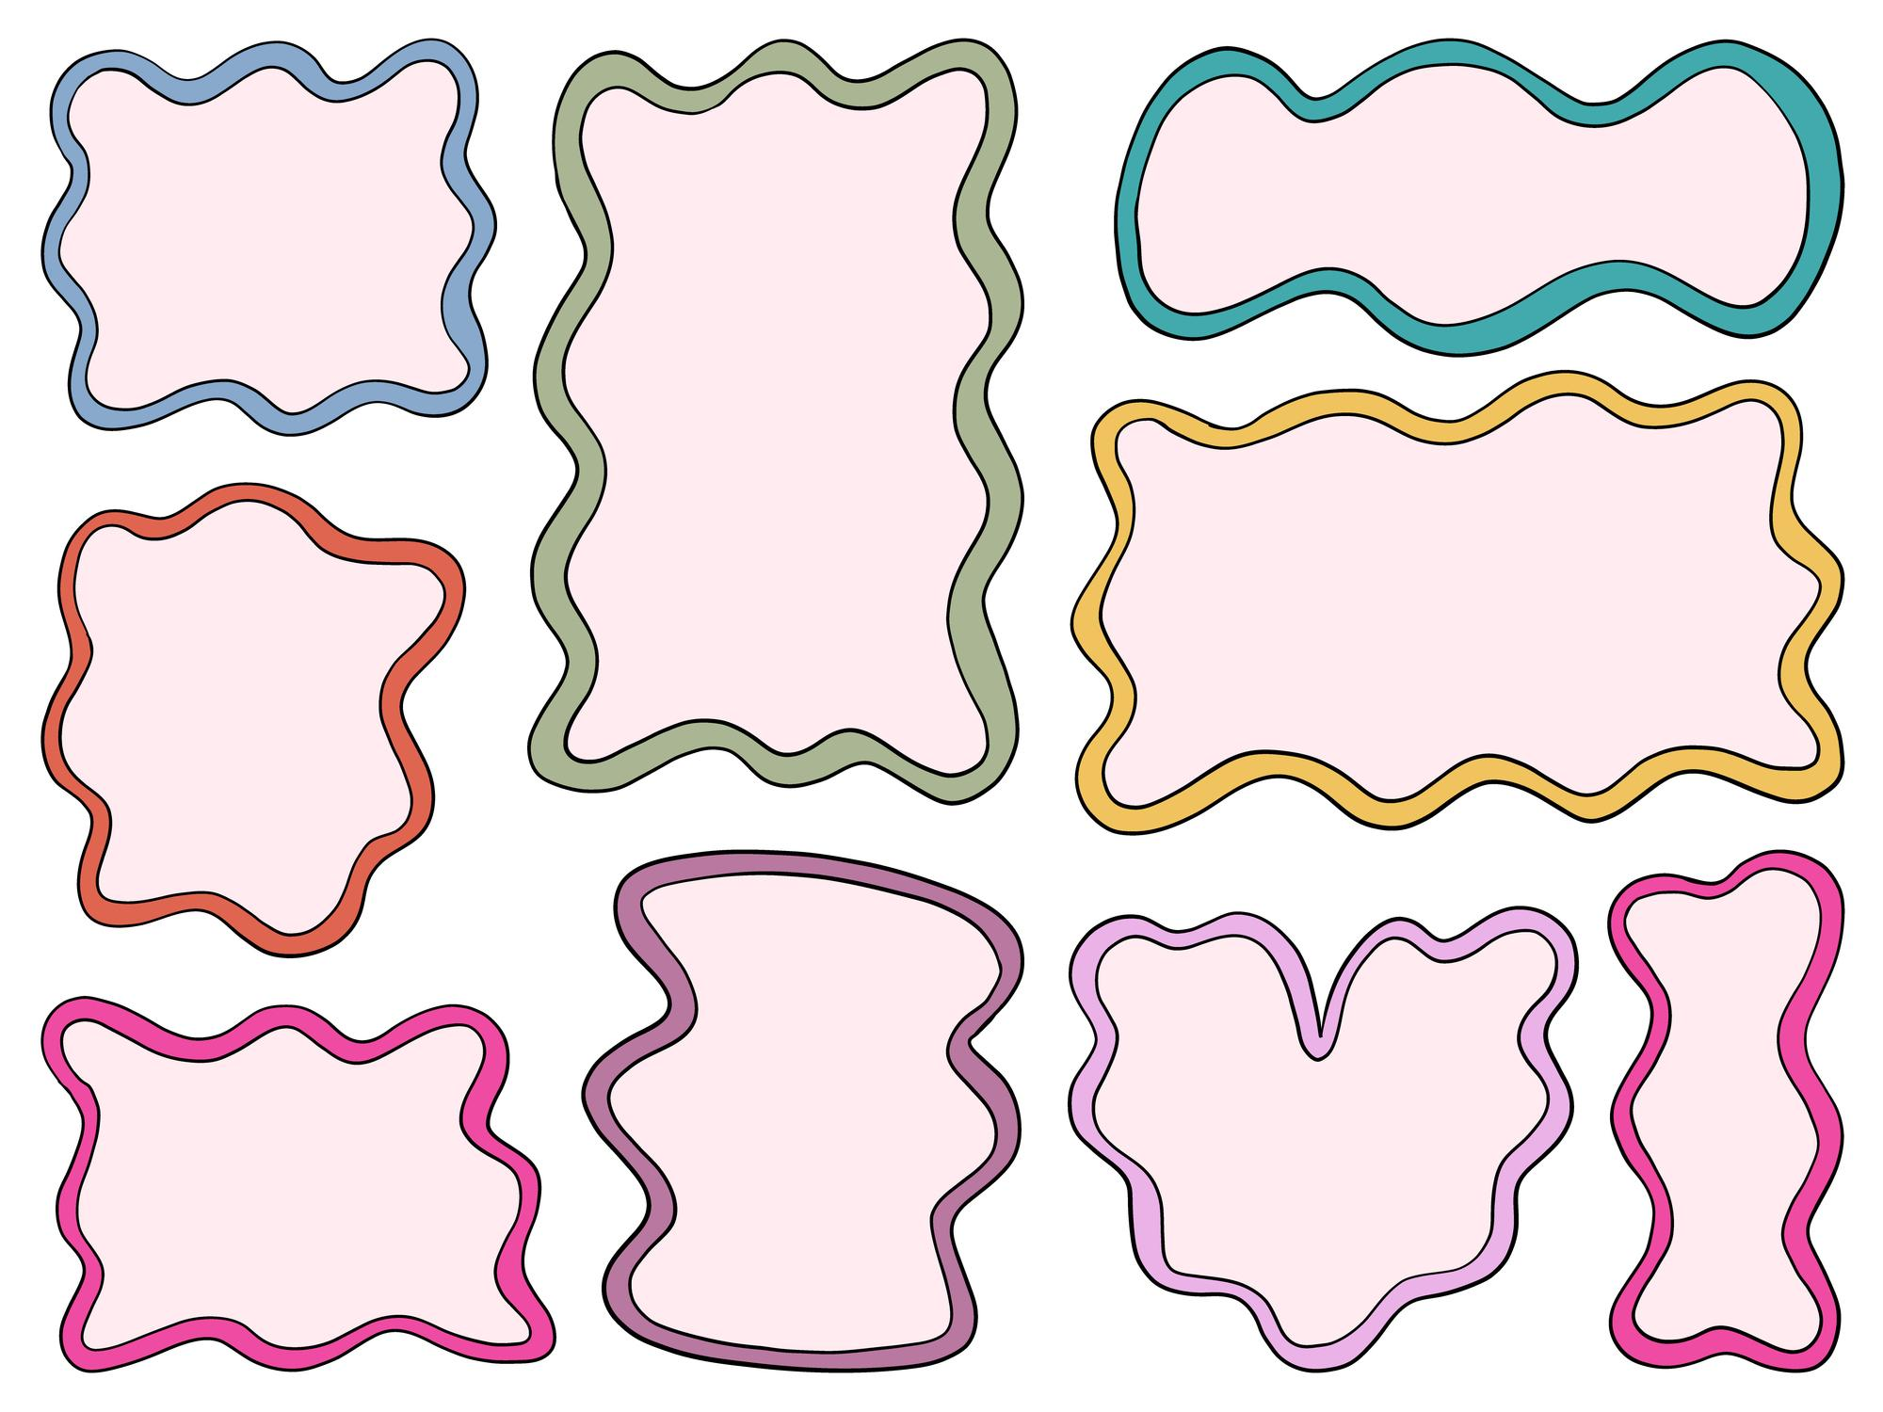
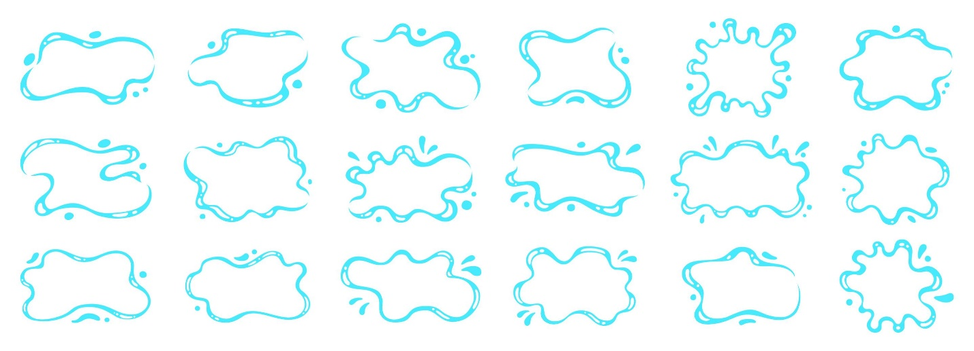
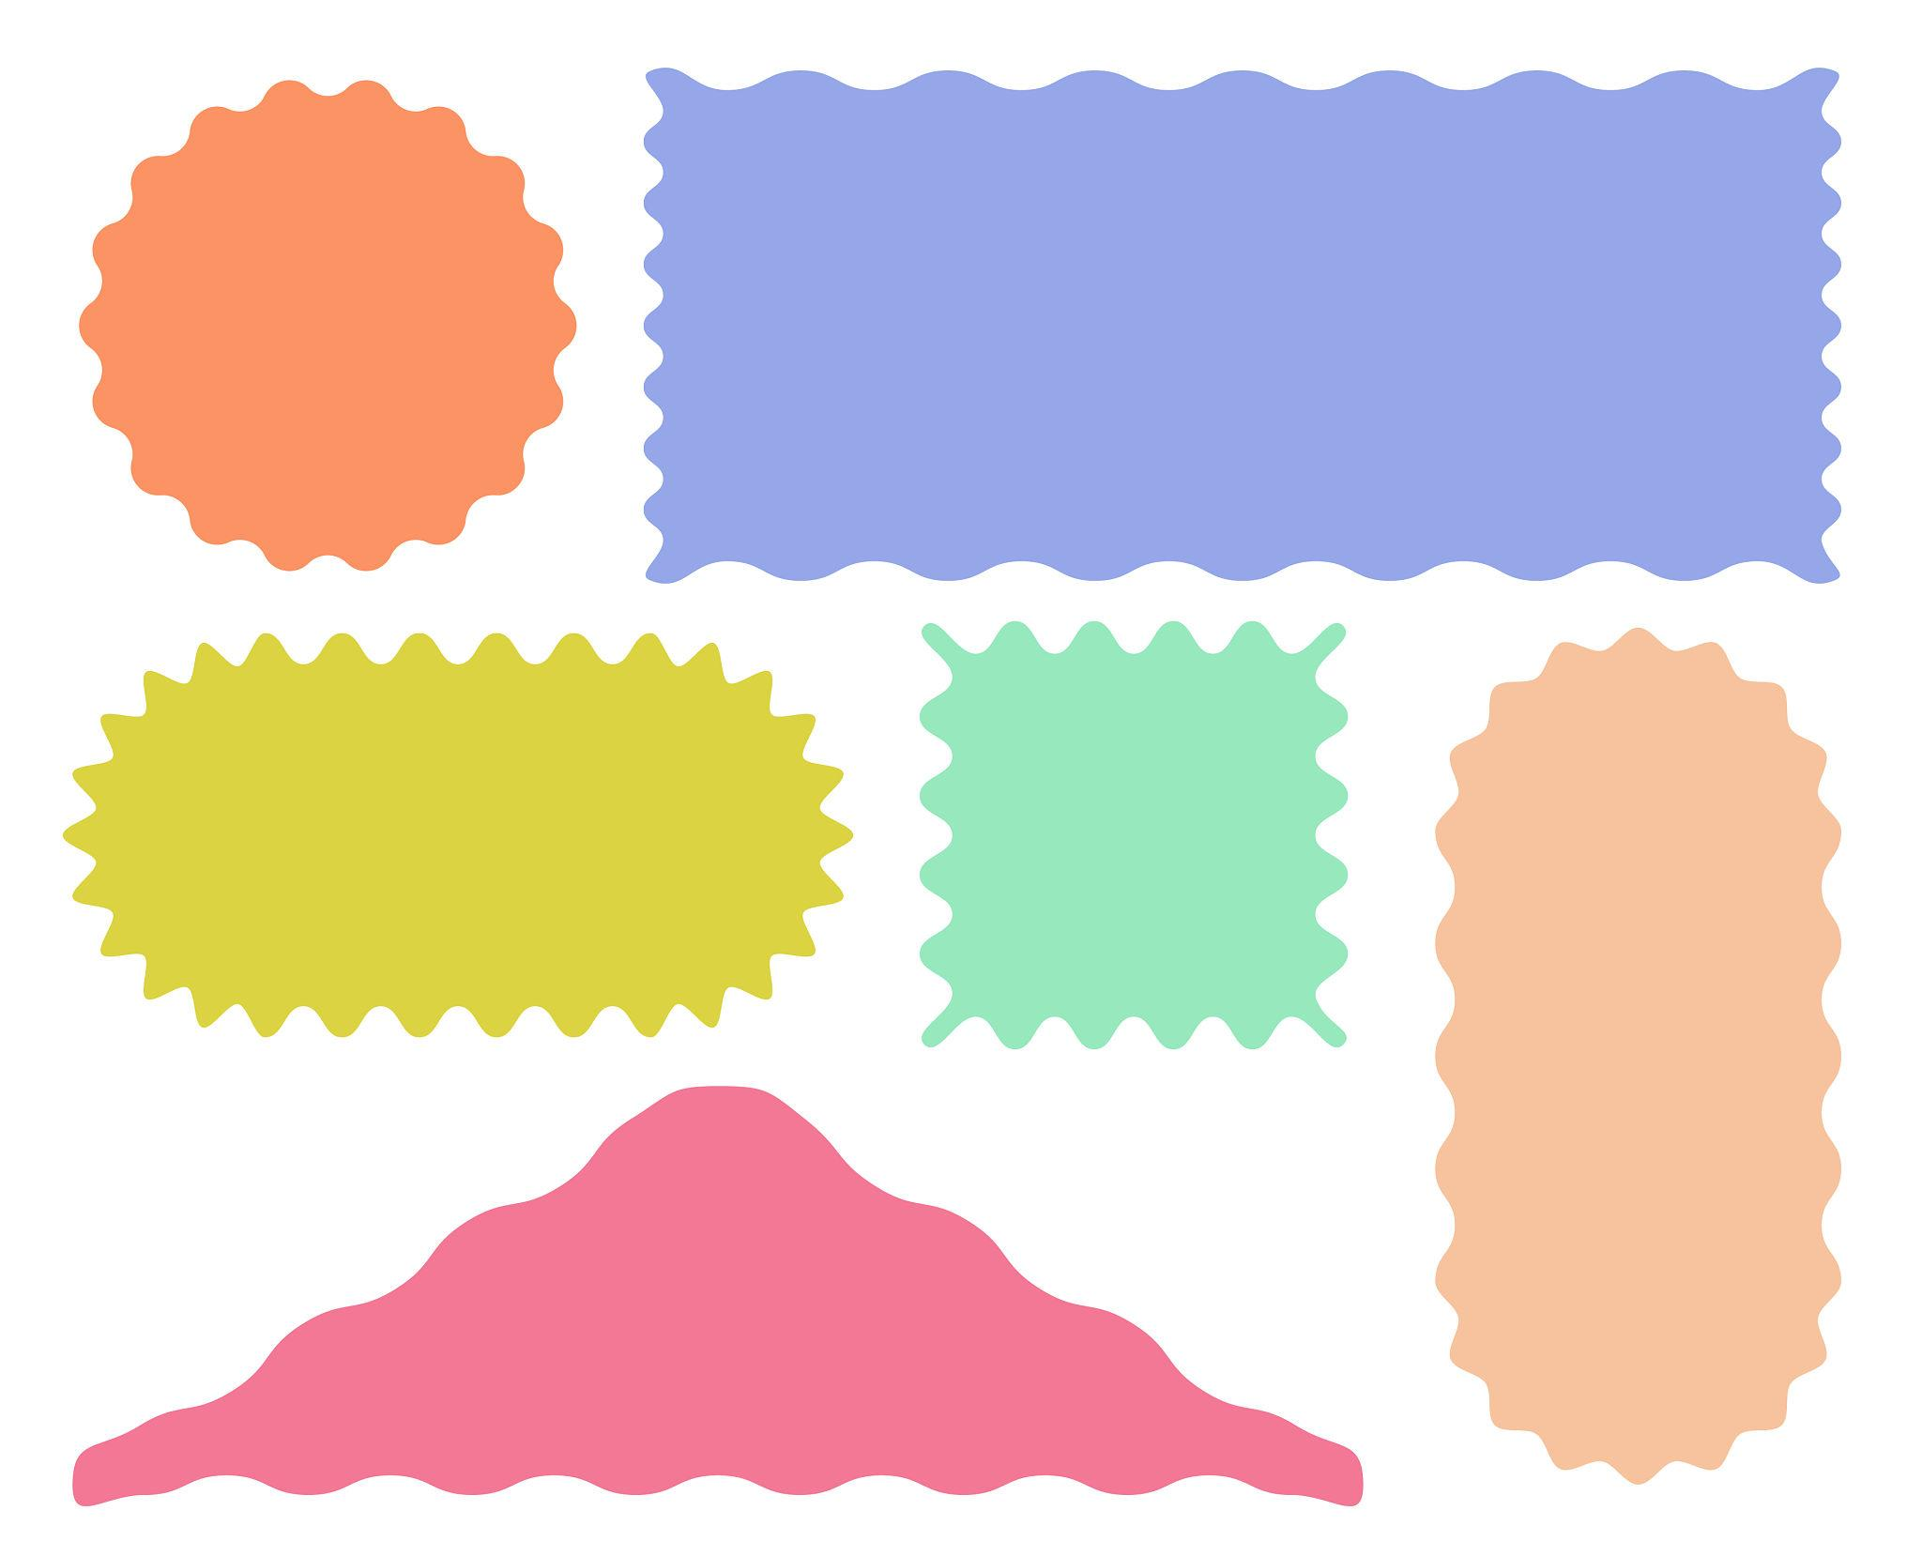
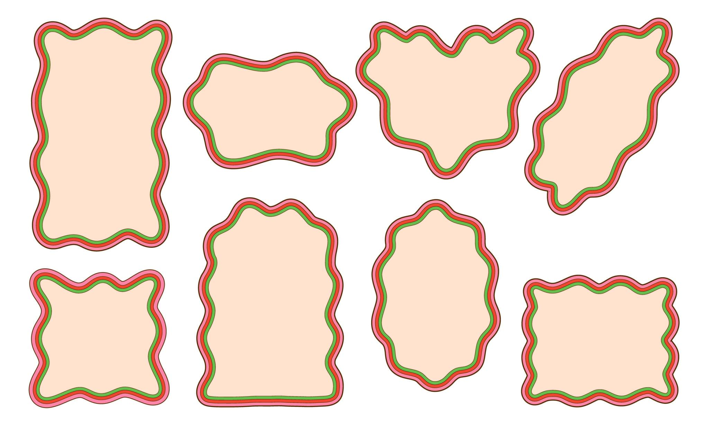
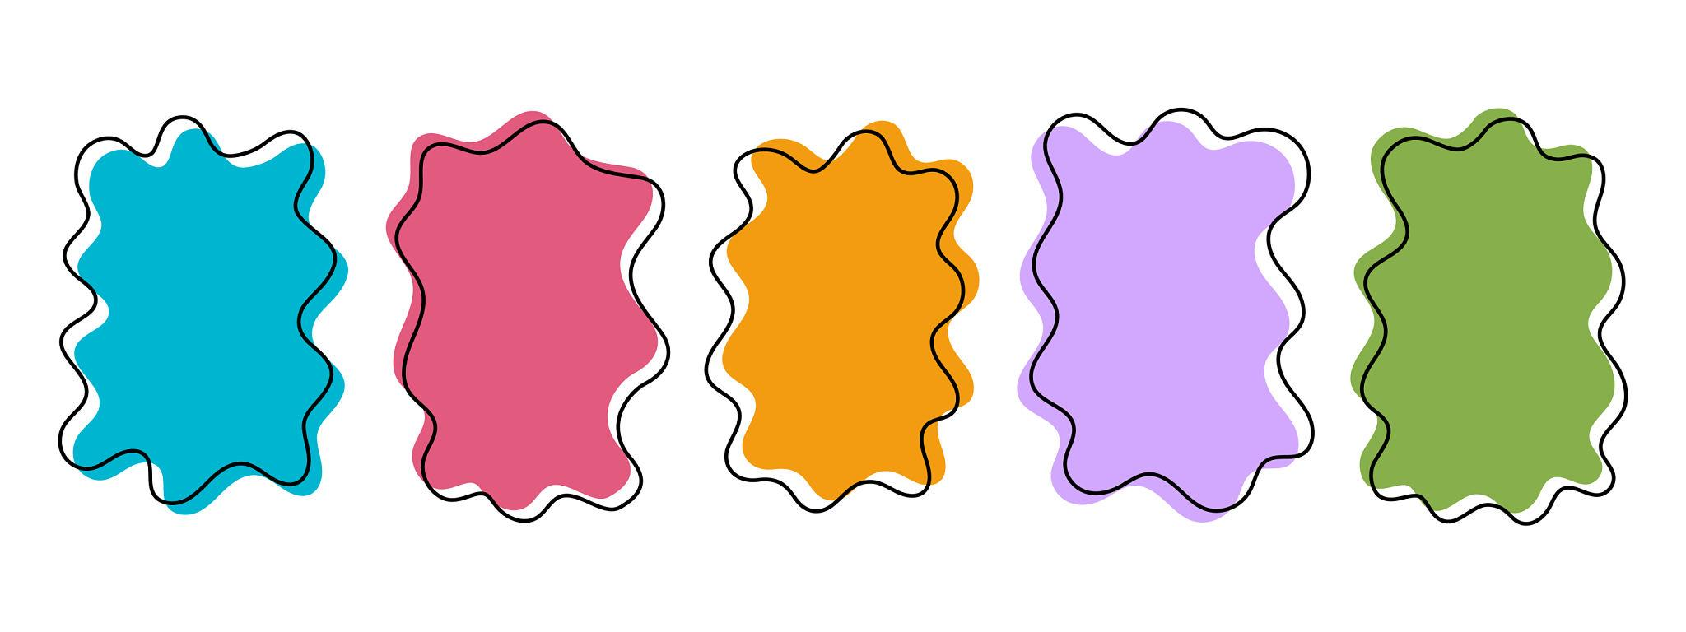

Classification Summary
# Source: AI Source: Provided by: [Data Path: Persons Table -> ID Column: 1, Name_En Column: Motasem Essam] -> From: [ChatGPT] on [7/25/2026]
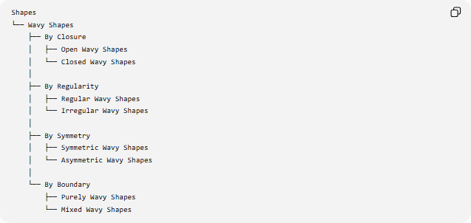
Shapes
└── Wavy Shapes
├── By Closure
│ ├── Open Wavy Shapes
│ └── Closed Wavy Shapes
│
├── By Regularity
│ ├── Regular Wavy Shapes
│ └── Irregular Wavy Shapes
│
├── By Symmetry
│ ├── Symmetric Wavy Shapes
│ └── Asymmetric Wavy Shapes
│
└── By Boundary
├── Purely Wavy Shapes
└── Mixed Wavy Shapes

Key Points
# Source: AI Source: Provided by: [Data Path: Persons Table -> ID Column: 1, Name_En Column: Motasem Essam] -> From: [ChatGPT] on [7/25/2026]
- A Wavy Shape has a smooth, wave-like boundary.
- Its direction changes continuously rather than through sharp corners.
- It is generally composed of curves rather than straight segments.
- It can be open or closed.
- It can be regular or irregular.
- It can be symmetric or asymmetric.
- A regular wavy form can be modeled using functions such as $y=Asin⁡\left(Bx\right)$.
- Wavy shapes differ from zigzag shapes mainly through smooth versus angular direction changes.
- A wavy shape can also be freeform or organic.

Conclusion
# Source: AI Source: Provided by: [Data Path: Persons Table -> ID Column: 1, Name_En Column: Motasem Essam] -> From: [ChatGPT] on [7/25/2026]
A Wavy Shape is a shape or form characterized by a smooth sequence of rises and falls. Its boundary typically contains continuous curves without sharp vertices, making it distinct from angular zigzag shapes. Wavy forms can range from mathematically regular waves to highly irregular freeform and organic shapes.

